**Drawing Shapes using VertexArray (more complex)**

https://www.youtube.com/watch?v=5GkcGw09D8w&t=417s

#include "stdafx.h"

#include "SFML/Graphics.hpp"

#include <iostream>

#include <windows.h>

int main()

{

sf::RenderWindow window (sf::VideoMode(600, 600), "SFML works!");

sf::VertexArray lines(sf::LinesStrip, 3);

lines[0].position = sf::Vector2f(50, 40);

lines[0].color = sf::Color::Red;

lines[1].position = sf::Vector2f(300, 50);

lines[1].color = sf::Color::Green;

lines[2].position = sf::Vector2f(200, 200);

lines[2].color = sf::Color::Blue;

sf::VertexArray trianglesStrip(sf::TrianglesStrip, 4);

trianglesStrip[0].position = sf::Vector2f(300, 300);

trianglesStrip[0].color = sf::Color::Cyan;

trianglesStrip[1].position = sf::Vector2f(500, 400);

trianglesStrip[1].color = sf::Color::Magenta;

trianglesStrip[2].position = sf::Vector2f(500, 500);

trianglesStrip[2].color = sf::Color::White;

trianglesStrip[3].position = sf::Vector2f(400, 500);

trianglesStrip[3].color = sf::Color::Green;

// goes up in order of triangle index

// triange[3] was formed from the last 2 vertexes

sf::VertexArray trianglesFan(sf::TrianglesFan, 4);

trianglesFan[0].position = sf::Vector2f(100, 470);

trianglesFan[0].color = sf::Color::Yellow;

trianglesFan[1].position = sf::Vector2f(40, 430);

trianglesFan[1].color = sf::Color::White;

trianglesFan[2].position = sf::Vector2f(140, 400);

trianglesFan[2].color = sf::Color::Green;

trianglesFan[3].position = sf::Vector2f(140, 550);

trianglesFan[3].color = sf::Color::Blue;

while (window.isOpen()) {

sf::Event event;

while (window.pollEvent(event)) {

switch (event.type) {

case sf::Event::Closed:

window.close();

break;

}

}

window.clear();

window.draw(lines);

window.draw(trianglesStrip);

window.draw(trianglesFan);

window.display();

}

}

*

*

*

*

*

*

*

*

*

*

*

*

*

*

V

**Result**

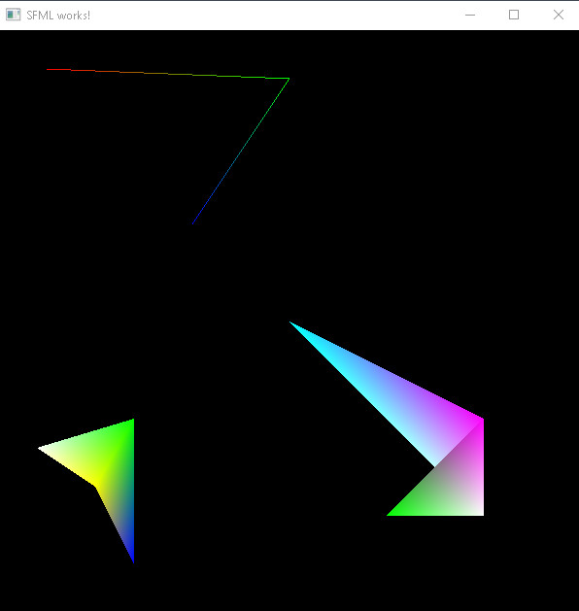

**Important points:**

* By using TrianglesStrip, you can create multiple triangles after 2nd index – after that, triangles can be created using the last two vertices used
* TrianglesFan, on the other hand, uses the first index as its center and creates triangles from it. The indexes 1,2,3 etc. are the edges of the other triangles